Job Description

Enabled Youth Disability Network (EYDN)
Co-design Member

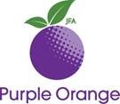
About Purple Orange
JFA Purple Orange is an independent South Australian organisation

The work JFA Purple Orange does is to help people who live with disability get a fair go.

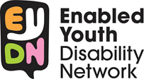
About Enabled Youth Disability Network (EYDN)
EYDN is a group for young people living with disability.

We speak up for things important to us and help other people learn how to speak up for themselves.

About the Job
This job is for a person who lives with a disability.
You will work as a co-design member with our project staff.
The project is for Enabled Youth Disability Network to help co-design.

Co-design is when people living with disability help EYDN and give advice.
Advice is when you tell someone what you think.

This is a voluntary non-paid job.
You will work different hours and different days.

Some weeks you might have no work.

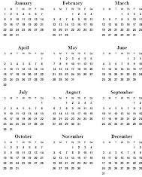
The job will be for 10 hours.

Things you will do in the job
Co-design members will work with:
- Project Staff in the city.
or
- Project Staff in the country.

Some of the jobs the co-design group will do are:
- Give ideas for the new workshops.
- Make decisions.
- Give feedback.
- Give advice to project workers.

Things you must be able to do or have

Experience
- Live with a disability.
- Live in the city or country.

Good presentation skills
- Speak clearly.
- Share stories.

Good organisation skills
- Follow instructions.
- Ask questions.

Confident and friendly person
- Work well with other people.
- Be respectful to others.

Access to reliable transport
- Be able to arrive at meetings on time.

How to apply for this job

To apply for this job you must:
Answer the questions on the application form
It is ok for someone to help you fill in the form

Please click here for the application form.
Apr 1

Send your answers to Sarah by 9am, 10th May, 2021.

sarahf@purpleorange.org.au

104 Greenhill Road
Unley SA 5061

If you need help or have any questions, please contact Sarah Footner.

(08) 8373 8388

